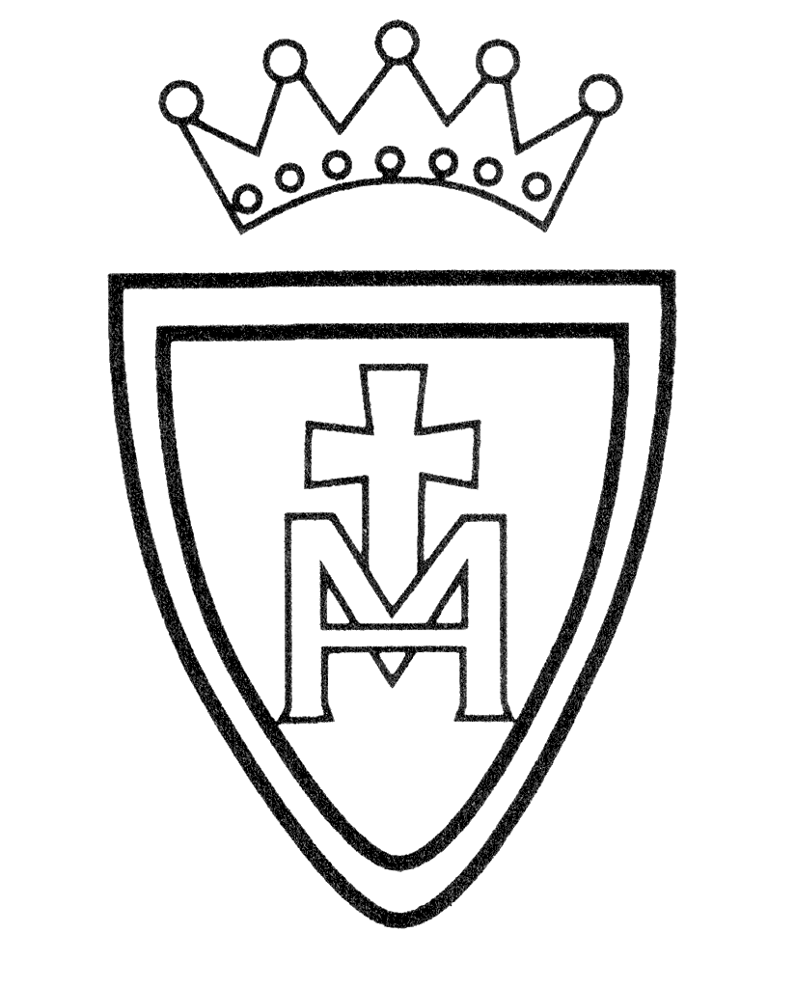History Curriculum Plan

Year Group | Autumn | Spring | Summer
Nursery | Families. Growing and changing. | Mary Anning – Dinosaurs. | Transport – Then and Now
Reception | Neil Armstrong and Tim Peake | Comparing and contrasting traditional tales | Seaside/Transport – Then and Now.
Year 1 | Gunpowder Plot | Our Church and School | Travel and Transport
Year 2 | Eccles Cenotaph | Great Fire of London | Florence Nightingale , Mary Seacole & Edith Cavell
Year3 | Stone Age to Iron Age | Ancient Greeks | Rainhill Trials and George Stephenson
Year 4 | Mayan Civilisation | Anglo Saxons and Scots | Roman Empire and its impact on Britain
Year 5 | Tudor Monarchs | Leisure and Entertainment | Manchester Industrial Revolution and Canals
Year 6 | Vikings | Christmas Blitz  Salford and WW2 | Ancient Egypt

