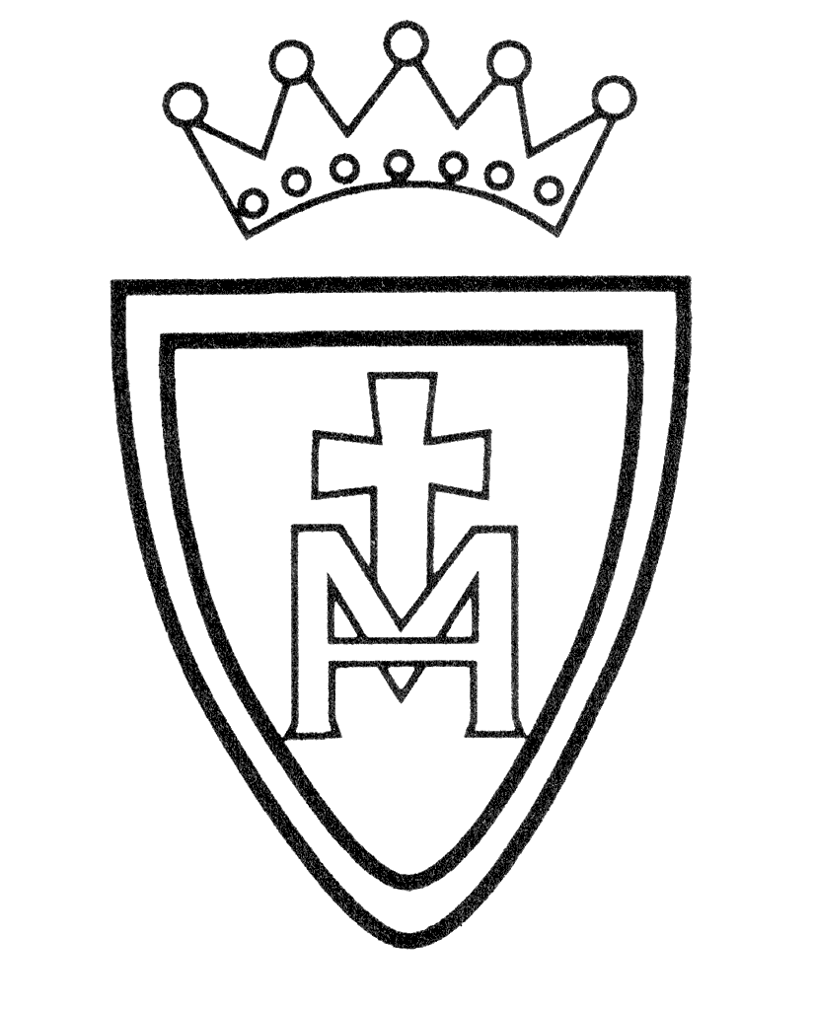MFL – French Curriculum Plan

Year Group | Autumn | Spring | Summer
Year3 | Ourselves  Celebrations | School  Weather | Hobbies  Holidays
Year 4 | Ourselves  Celebrations | School  Weather | Hobbies  Holidays
Year 5 | Masculine & feminine nouns  Adjectives  Verbs  Adverbs of place  Adverbs of time  Numbers up to 60  Christmas | Telling the time  Verbs  Simple negative  Pronouns (subjective, disjunctive, relative)  Where is? (Ou est?) and adverbs of place.  Negatives: eg le chat ne nage pas (the cat is not swimming).  Prépositions Je/Il/Elle | French & healthy foods  Expression of opinion  Expressions of annoyance, joy...  Immediate future tense  Conjunctions
Year 6 | Spoken French Revision:  Pronunciation (alphabet, tongue twisters & songs)  Hymns (Hail Mary & O Come Lord)  Revise numbers up to 60  Questions & answers | French grammar and number development  Masculine & feminine nouns (animals)  Verbs (present tense)  Numbers up to 60-100  Asking questions  Telling the time | Further French grammar and number development  Adverbs of place  Adverbs of time  Telling the time (answering questions)  Times tables

