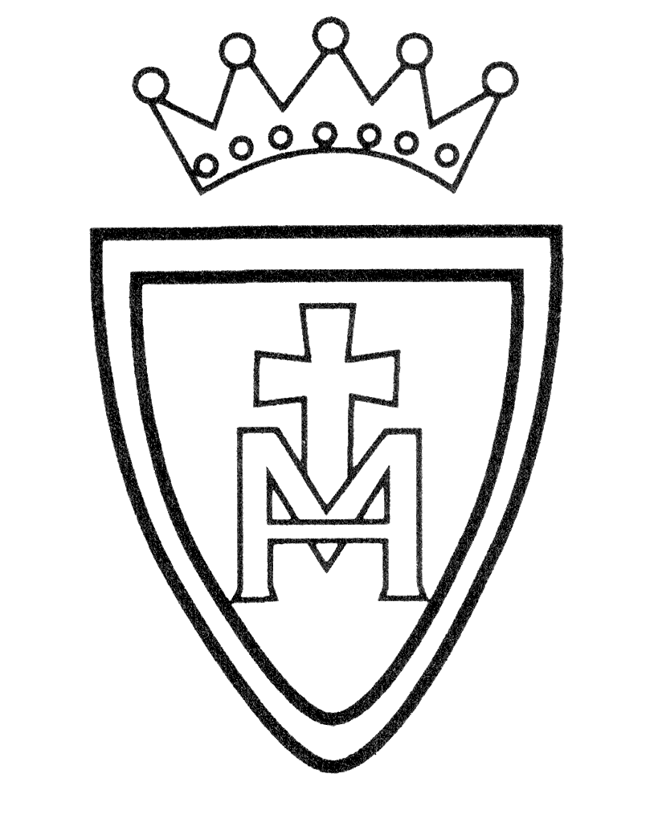DT Curriculum Plan

Year Group | Mechanisms | Structures | Textiles | Digital World | Electrical Systems (KS2) | Food & Nutrition
Nursery | Cooking & Nutrition  Playdough - sculpture  Junk Modelling  Joining Materials
Reception | Creating masks  Cooking & Nutrition  Junk Modelling  Joining Materials
Year 1 | Wheels & axles | Constructing  windmills |  |  |  | Smoothies
Year 2 | Wheels & axles |  | Pouches |  |  | Balanced diet:  Wraps
Year3 |  | Constructing a castle | Digital world wearable technology | Wearable  Technology |  | Eating Seasonally:  Seasonal tarts
Year 4 | Slingshot Cars |  |  |  | Torches | Adapting a recipe:  Pizzas
Year 5 |  | Bridges | Stuffed animals |  |  | Developing a recipe:  Bolognaise
Year 6 |  |  |  | Navigating the World | Steady hand game | Come Dine With Me  (St. Mary’s  Kitchen)

Pupils will also take part in the ‘Imagine you are an engineer’ competition each year.

