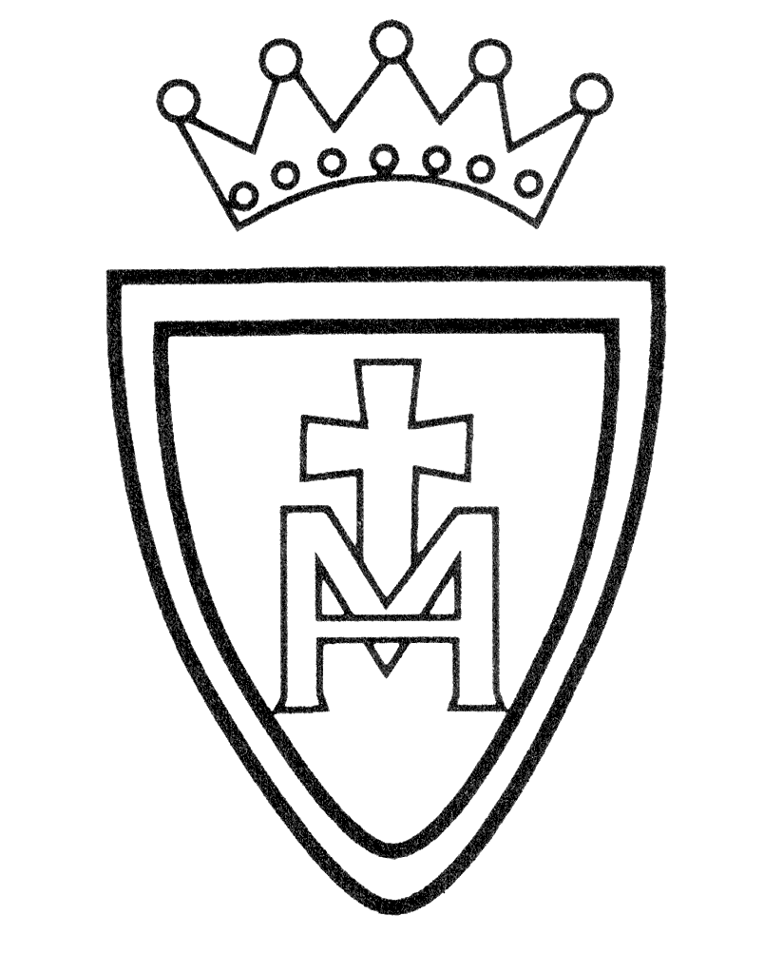Art Curriculum Plan

2021-2022

Year Group | Autumn | Spring | Summer
Nursery | Mark Making  Self Portraits  Leaf Printing | Colour Mixing  Exploring Textures | Van Gogh  Creating Collaboratively
Reception | Self Portraits  Colour Mixing  Rangoli Patterns | Kandinksky  Observational Drawings | Creating Collaboratively  Collage and Mixed Media
Year 1 | Flowers  Van Gogh  Georgia O’Keefe  (printing) | Africa  Tingatinga  Henri Rosseau  (collage) | Earth Art  Andy Goldsworthy  Richard Long  Natural sculpture
Year 2 | Seascapes  Lowry  Hokusai  (textiles/weaving) | Colour  Kandinsky  Miro  (Abstract Digital Art) | Fantastic Creatures  Clay coil pots
Year3 | Portraits  Picasso  (collage) | Stone Age Art  (printing) | Birds  Dianna Beltran Hererra Paul Harvey  wire and card birds
Year 4 | People  Giometti  Lowry | Trees -  Pattern &  Textiles  William Morris  Orla Kiely  Laura Ashley  (printing & textiles) | Polar Bears  Monster Chetwynd  Recycled materials & modroc
Year 5 | Mexico  Frida Kahlo  Leonora Carrington  (collage) | Cityscapes  Lowry  Daniel Libeskind  Stephen Wiltshire  (digital art) | Islamic Art  clay tiles
Year 6 | Street Art  Banksy  Keith Haring  (collage) | WWII Fashion  (textiles) | My Sculptural Self  wire and textile people

