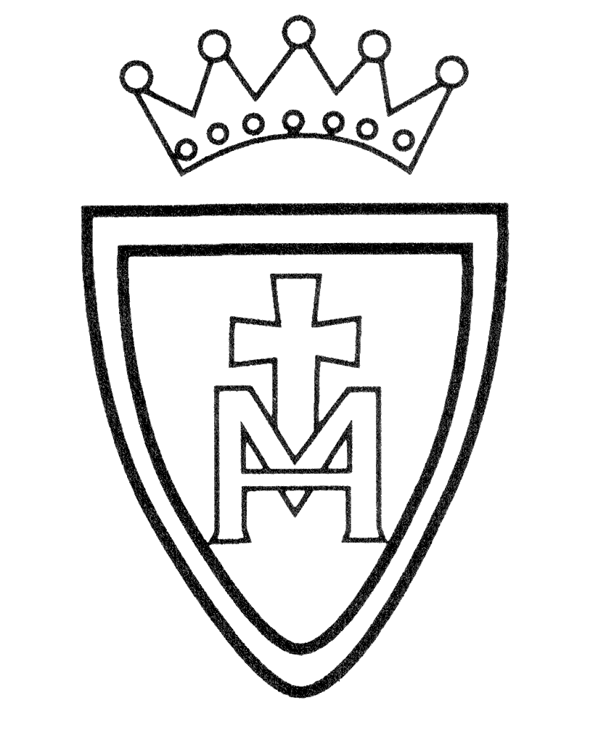Computing Curriculum Plan

2022-2023

Year Group | Autumn | Spring | Summer
Nursery | IWB Games | Taking photos on ipad | Beebots
Reception | IWB Games | Taking photos on ipad | Beebots
Year 1 | Digital Literacy -  There’s an App for That  Computer Science | Online Safety  Digital Literacy – Becoming Digital Authors | ICT – Living with Technology  Cross Curricular Technology
Year 2 | Computer Science | Online Safety –Safe surfin  Digital Literacy – Cubitects | ICT  Cross Curricular Technology
Year3 | Computer Science - Hello world!  Computer Science (robotics)  Communication | Online Safety - My Life online  Digital Literacy  3D Design | ICT  Ada Lovelace  Cross Curricular Technology
Year 4 | Computer Science  Cake Factory  Computer Science (robotics)  Robot Factory | Online Safety - My Life online  Digital Literacy  Sphero Movie Trailer | ICT  Steve Jobs  Cross Curricular Technology
Year 5 | Computer Science  Game Studio  Computer Science (robotics)  Autonomous Vehicles | Online Safety - My Life online  Digital Literacy  Still Image Editing | ICT  Alan Turing  Cross Curricular Technology
Year 6 | Computer Science  Star Chaser  Computer Science (robotics) Game Development | Online Safety - My Life online  Digital Literacy Arthouse Animation | ICT  Katherine Johnson  Cross Curricular Technology

